**Weather Prediction**

**A**

**Real Time Research/Societal Project Report**

***Submitted to***



# Jawaharlal Nehru Technological University, Hyderabad

*In partial fulfilment of the requirements for the*

*award of the degree of*

**BACHELOR OF TECHNOLOGY**

**In**

**COMPUTER SCIENCE AND ENGINEERING**

By

**ADARSH P R 23VE1A05k3**

**MALOTHU SIDDHU 23VE1A05N0**

**VALLURI NAGESHWARI 23VE1A05R3**

**ENJETI DEEPTHI 24VE5A0521**

## **Under the Guidance**

**of**

**Mr.M. HARI PRASAD**

**ASSISTANT PROFESSOR**



## SREYAS INSTITUTE OF ENGINEERING AND TECHNOLOGY

**DEPARTMENT OF COMPUTER SCIENCE AND ENGINEERING**

(Affiliated to JNTUH, Approved by A.I.C.T.E and Accredited by NAAC, New Delhi)

Beside Indu Aranya, Nagole, Hyderabad-500068, Ranga Reddy Dist.

**(2023-2027)**



# **SREYAS INSTITUTE OF ENGINEERING AND TECHNOLOGY**

**DEPARTMENT OF COMPUTER SCIENCE AND ENGINEERING**

# **CERTIFICATE**

This is to certify that the Real Time Research/societalProject Report on **“Weather Prediction”** submitted by **Adarsh PR , Malothu Siddhu, Valluri Nageshwari, Enjeti Deepthi** bearing Hall ticket numbers: **23VE1A05k3, 23VE1A05N0, 23VE1A05R3, 24VE5A0521** in partial fulfillment of the requirements for the award of the degree of **Bachelor of Technology** in **COMPUTER SCIENCE AND ENGINEERING** from **SREYAS INSTITUTE OF ENGINEERING AND TECHNOLOGY**, Nagole, Hyderabad for the academic year 2024-2025 is a record of bonafide work carried out by them under our guidance and Supervision.

.

|  |  |
| --- | --- |
| **Project Coordinator** | **Head of the Department** |
| **Dr.T.SWARNALATHA REDDY** | **Dr. U. M. FERNANDES DIMLO** |
| **Professor** | **Professor & Head** |
| **Internal Guide**  **Mr. M.HARI PRASAD**  **Assistant Professor** | **External Examiner** |



## **SREYAS INSTITUTE OF ENGINEERING AND TECHNOLOGY**

**DEPARTMENT OF COMPUTER SCIENCE AND ENGINEERING**

**DECLARATION**

We **Adarsh PR , Malothu Siddhu, Valluri Nageshwari, Enjeti Deepthi** bearing Hall ticket numbers: **23VE1A05k3, 23VE1A05N0, 23VE1A05R3, 24VE5A0521** hereby declare that the Real Time Research/societalProject titled **WEATHER PREDICTION** done by us under the guidance of **Mr.M.HARI PRASAD, Assistant Professor** which is submitted in the partial ful fillment of the requirementfor the award of the B.Tech degree in **Computer Science and Engineering at Sreyas Institute of Engineering and Technology** for Jawaharlal Nehru Technological University, Hyderabad is our original work.

**ADARSH P R (23VE1A05k3)**

**MALOTHU SIDDHU (23VE1A05N0)**

**VALLURI NAGESHWARI (23VE1A05R3)**

## **ENJETI DEEPTHI (24VE5A0521)**

**ACKNOWLEDGEMENT**

The successful completion of any task would be incomplete without mention of the people who made it possible through their guidance and encouragement crowns all the efforts with success.

We take this opportunity to acknowledge with thanks and deep sense of gratitude to **Mr.M.HARI PRASAD, Assistant Professor Department of Computer Science and Engineering** for his constant encouragement and valuable guidance during the Project work.

A Special vote of Thanks to **Dr. U. M. Fernandes Dimlo, Head of the Department** and **Dr.T.SWARNALATHA REDDY , Professor Project Coordinator** who has been a source of Continuous motivation and support. They had taken time and effort to guide and correct us all through the span of this work.

We owe very much to the **Department Faculty, Principal** and the **Management** who made our term at Sreyas Institute of Engineering and Technology a stepping stone for our career. We treasure every moment we had spent in college.

Last but not the least, our heartiest gratitude to our parents and friends for their continuous encouragement and blessings. Without their support this work would not have been possible.

**ADARSH P R (23VE1A05k3)**

**MALOTHU SIDDHU (23VE1A05N0)**

**VALLURI NAGESHWARI (23VE1A05R3)**

## **ENJETI DEEPTHI (24VE5A0521)**

## 

### ABSTRACT

### Weather prediction is a crucial scientific process that involves forecasting atmospheric conditions based on the analysis of meteorological data. Advanced techniques, including numerical weather prediction (NWP), machine learning models, and satellite observations, are used to improve accuracy. Traditional forecasting relies on physical models that simulate atmospheric behavior, while modern approaches integrate artificial intelligence (AI) and big data analytics to enhance predictions. The accuracy of weather forecasts is influenced by factors such as data quality, computational power, and the complexity of atmospheric interactions. Improved weather prediction is essential for disaster preparedness, agriculture, aviation, and daily life. Despite advancements, challenges such as sudden weather changes and model uncertainties persist. Future research focuses on enhancing predictive models using deep learning, quantum computing, and real-time data assimilation to achieve more precise and reliable forecasts.

**KEYWORDS**: Weather prediction, Forecasting, Atmospheric conditions, Meteorological data ,Numerical Weather Prediction (NWP), Machine learning, Satellite observations, Physical models, Artificial Intelligence (AI), Big data analytics, Forecast accuracy, Data quality, Computational power, Atmospheric interactions, Disaster preparedness, Agriculture, Aviation, Model uncertainties, Sudden weather changes, Predictive models, Deep learning , Quantum computing, Real-time data assimilation, Reliable forecasts

|  |  |  |  |
| --- | --- | --- | --- |
| **S.NO** |  | **TABLE OF CONTENTS** | **PAGE NO.** |
|  |  | ABSTRACT |  |
|  |  | LIST OF FIGURES |  |
|  |  | LIST OF ABBREVIATIONS |  |
| **1** |  | INTRODUCTION |  |
| 1.1 | Overview of the Project |  |
| **2** |  | LITERATURE SURVEY |  |
| **3** |  | AIM AND SCOPE OF THE PROJECT |  |
| 3.1 | Aim of the Project |  |
| 3.2 | Scope of the Project |  |
| **4** |  | MATERIALS AND METHODS USED |  |
| 4.1 | System Requirements |  |
| 4.1.1 | Hardware Requirements |  |
| 4.1.2 | Software Requirements |  |
| 4.1.2.1 | Front-End Part |  |
| 4.1.2.2 | Back-End Part |  |
| 4.1.3 | Python Language |  |
| 4.1.3.1 | Python Libraries and Frameworks |  |
| 4.1.3.2 | Versatility, Efficiency, Reliability and Speed |  |
| 4.1.3.3 | Visual Studio Code |  |
| 4.1.4 | Django |  |
| 4.1.4.1 | Complete |  |
| 4.1.4.2 | Versatile |  |
| 4.1.4.3 | Maintainable |  |
| 4.1.4.4 | Portable |  |
|  | **4.1.5** | Bootstrap |  |
| 4.1.5.1 | Features |  |
|  | 4.1.6 | Java Script |  |
| 4.1.6.1 | Application of Java Script |  |
| 4.1.6.2 | Features of Java Script |  |
| 4.1.7 | HTML |  |
|  | 4.2 | Design Methodology |  |
| 4.2.1 | Existing System |  |
| 4.2.2 | Proposed System |  |
| 4.3 | Module Description |  |
| 4.3.1 | Module 1: Interactive Web Application |  |
| 4.3.2 | Module 2: Location Based Prediction |  |
| 4.3.3 | Module 3: Graphical Representation |  |
|  | 4.4 | System Implementation |  |
|  | 4.4.1 | Architecture Explanation |  |
|  | 4.4.2 | Data Flow Explanation |  |
| **5**  5 | 5.1 | System Implementation |  |
|  | 5.2 | Code |  |
| 66666**6**  66666666 |  | Testing |  |
| 6.1 | Types of testing |  |
| 6.2 | TestCases |  |
|  | 6.3 | Code screenshots |  |
|  | 6.4 | Outputs |  |
| 7 | 7 | Conclusion and Future scopes |  |
|  | 8 | REFERENCES |  |
|  | 9 | APPENDIX |  |

**LIST OF SYMBOLS**

|  |  |  |  |
| --- | --- | --- | --- |
| **SNO.** | **Name of Symbol** | **Notation** | **Description** |
| 1 | CLASS |  | Represents a collection of similar entities grouped together. |
| 2 | ASSOCIATION |  | Associations represent static relationships between classes. Roles represent the way the two classes see each other. |
| 3 | ACTOR |  | It aggregates several classes into a single class. |
| 4 | RELATION (uses) | *Uses* | Used for additional process communication. |
| 5 | RELATION (extents) |  | Extends relationship is used when one use case is similar to another use case. |

|  |  |  |  |
| --- | --- | --- | --- |
| 6 | COMMUNICATION |  | Communication between various use cases. |
| 7 | STATE |  | State of the process |
| 8 | INITIAL STATE |  | Initial state of the object |
| 9 | FINAL STATE |  | Final state of the object |
| 10 | CONTROL FLOW |  | Represents various control flow between the states. |
| 11 | DECISION BOX |  | Represents decision  making process from a    constraint |
| 12 | USE CASE |  | Interact ion between the system and external environment. |

|  |  |  |  |
| --- | --- | --- | --- |
| 13 | COMPONENT |  | Represents physical modules which is a collection of components. |
| 14 | NODE |  | Represents physical modules which are a collection of components. |
| 15 | DATA PROCESS/ STATE |  | A circle in DFD represents a state or process which has been triggered due to some event or action. |
| 16 | EXTERNAL ENTITY |  | Represents external entities such as keyboard,  sensors, etc |
| 17 | TRANSITION |  | Represents communication that occurs between processes. |

|  |  |  |  |
| --- | --- | --- | --- |
| 18 | OBJECT LIFELINE |  | Represents the vertical dimensions that the object communications. |
| 19 | MESSAGE |  | Represents the message exchanged. |

**CHAPTER – 1**

**INTRODUCTION**

**1.1 Overview of the Project**

Weather prediction plays a vital role in modern society by providing essential information about future atmospheric conditions. Accurate weather forecasts help individuals, businesses, and governments make informed decisions in areas such as disaster management, agriculture, aviation, and day-to-day planning. This project, titled **"Weather Prediction System,"** aims to develop an intelligent forecasting model by integrating traditional meteorological techniques with modern technologies such as **machine learning (ML), artificial intelligence (AI), satellite imaging**, and **numerical weather prediction (NWP)**.

The system works by collecting vast amounts of **historical and real-time weather data** from various sources, including satellites, sensors, and meteorological stations. This data is then analyzed and processed using machine learning algorithms that have been trained to recognize patterns and trends in weather behavior. The primary goal is to predict key weather parameters such as temperature, humidity, rainfall, wind speed, and atmospheric pressure with high accuracy.

Unlike traditional models that rely solely on physical simulations of the atmosphere, this system leverages the power of **AI and big data analytics** to identify complex relationships in data that are often too intricate for manual analysis. This hybrid approach improves the overall accuracy and reliability of forecasts, making the system more adaptable to changing weather patterns and climate variability.

**Key Features and Advantages:**

* **AI-Powered Forecasting:** Machine learning algorithms enhance prediction accuracy by learning from historical patterns.
* **Real-Time Data Integration:** Continuously updates with real-time data from satellite and ground-based sources.
* **Scalability:** Can be expanded to cover large geographic areas and multiple weather parameters.
* **User-Friendly Output:** Presents forecast information in a clear, accessible format for different types of users.
* **Future-Ready:** Supports integration of **deep learning** techniques and **quantum computing** for even greater performance in future developments.

**Applications of the System:**

1. **Disaster Preparedness:** Early warnings for floods, cyclones, and storms can save lives and minimize damage.
2. **Agriculture:** Helps farmers plan irrigation, sowing, and harvesting based on accurate weather data.
3. **Aviation and Transportation:** Provides real-time updates to ensure flight and travel safety.
4. **Public Utility Services:** Assists in managing energy distribution and other weather-sensitive services.

**Challenges Addressed:**

* Sudden and unpredictable weather changes
* Incomplete or low-resolution data
* Limitations of traditional forecasting models
* Model uncertainty and lack of real-time adaptability
  + **Future Enhancements:**
  + The project aims to further enhance predictive capabilities by incorporating:
  + **Deep learning architectures** such as Recurrent Neural Networks (RNNs) and Convolutional Neural Networks (CNNs)
  + **Quantum computing** for faster processing and more accurate simulation
  + **Advanced real-time data assimilation** from IoT weather sensors and drones

**CHAPTER – 2**

**Literature Survey**

Weather prediction has been a major area of scientific research for decades, evolving from basic observational methods to advanced computational models. Recent developments in artificial intelligence, machine learning, and data analytics have further transformed weather forecasting, making it more accurate and efficient. This literature survey presents a review of existing methods, technologies, and research contributions related to weather prediction systems.

**1. Traditional Weather Forecasting Techniques**

Historically, weather forecasting relied heavily on **Numerical Weather Prediction (NWP)** models, which use mathematical equations to simulate the behavior of the atmosphere. These models consider physical laws such as thermodynamics, fluid dynamics, and radiative transfer.

**Global Forecast System (GFS)** and **European Centre for Medium-Range Weather Forecasts (ECMWF)**

are widely used NWP models.

Limitations: High computational requirements, sensitivity to initial conditions, and difficulty in handling rapid

or localized weather changes.

**2. Statistical and Regression-Based Methods**

Before the widespread use of AI, **statistical models** such as linear regression, time-series analysis, and autoregressive models (ARIMA) were commonly used to predict temperature, rainfall, and humidity based on historical patterns.

**Pros**: Easier to implement and interpret.

**Cons**: Less accurate for complex or non-linear weather patterns.

**3. Machine Learning in Weather Forecasting**

Recent advancements have introduced **machine learning (ML)** approaches, which learn patterns from historical data and make data-driven predictions.

**Support Vector Machines (SVM)**, **Random Forests**, and **K-Nearest Neighbors (KNN)** have been used

for predicting temperature, precipitation, and air quality.

**Artificial Neural Networks (ANN)** are effective in modeling non-linear relationships in meteorological

data.

**Example:**  
Kumar et al. (2019) implemented an ANN-based system to predict rainfall with promising accuracy, outperforming traditional regression models.

**4. Deep Learning Techniques**

Deep learning methods, especially **Recurrent Neural Networks (RNNs)** and **Long Short-Term Memory (LSTM)** networks, are well-suited for sequential data such as time-series weather data.

* LSTM networks can retain long-term dependencies and trends, making them ideal for multi-day forecasts.
* CNNs (Convolutional Neural Networks) are also used to analyze spatial patterns in satellite images and radar data.

**Example:**  
Wang et al. (2021) used LSTM networks to forecast hourly temperature and achieved significantly improved performance over standard ML models.

**5. Satellite and Remote Sensing Data Integration**

The integration of **satellite imagery**, radar data, and remote sensing techniques helps improve spatial accuracy and real-time monitoring capabilities.

* NASA's **MODIS** and **NOAA's GOES** satellites provide crucial data for climate and weather analysis.
* These inputs are often used in hybrid models combining ML with NWP for more accurate forecasts.

**6. Challenges in Current Research**

* Handling **missing or inconsistent data**.
* Coping with **sudden atmospheric changes** and **extreme weather events**.
* Balancing model complexity with **computational efficiency**.
* Limited availability of **high-resolution real-time data**.

**7. Research Gaps and Future Directions**

* Need for **multi-modal learning** combining text, images, and sensor data.
* **Quantum computing** to process large weather datasets faster.
* **Real-time adaptive systems** that update predictions dynamically.
* Exploration of **transfer learning** for applying models across different geographic regions.

**CHAPTER – 3**

**AIM AND SCOPE OF THE PRESENT INVESTIGATION**

**3.1 Aim**

The primary aim of the present investigation is to develop an intelligent and accurate **Weather Prediction System** that utilizes **machine learning (ML)** and **artificial intelligence (AI)** techniques to forecast atmospheric conditions such as **temperature, humidity, rainfall, and wind speed**. The system is designed to overcome the limitations of traditional weather prediction models by integrating **real-time data**, **satellite observations**, and **advanced algorithms** to enhance the reliability, accuracy, and efficiency of weather forecasts.

**3.2 Scope:**

The scope of this project includes the following major areas of investigation and development:

1. **Data Collection and Preprocessing:**
   * Gathering **historical and real-time meteorological data** from trusted sources (e.g., weather stations, satellites, online APIs).
   * Preprocessing the data to handle missing values, normalize features, and structure it for training machine learning models.
2. **Model Development:**
   * Designing and training machine learning models such as **Linear Regression**, **Decision Trees**, and **LSTM (Long Short-Term Memory)** networks for time-series weather forecasting.
   * Comparing model performances and selecting the best-performing algorithm.
3. **Prediction Capabilities:**
   * Forecasting multiple weather parameters, including:
     + Temperature
     + Rainfall
     + Humidity
     + Wind speed
4. **Real-Time Forecasting System:**
   * Developing a **user-friendly interface** or application that displays live weather predictions.
   * Updating forecasts based on continuously incoming real-time data.
5. **Application Domains:**
   * **Agriculture**: Helping farmers plan crop cycles and irrigation.
   * **Disaster Management**: Providing early warnings for floods, storms, and heatwaves.
   * **Aviation and Transportation**: Ensuring safe travel by predicting adverse weather conditions.
   * **Daily Use**: Offering accessible weather updates for the general public.
6. **Research Advancement:**
   * Exploring the use of **deep learning**, **big data analytics**, and potentially **quantum computing** for enhancing prediction speed and accuracy.
   * Investigating model scalability across different geographic regions and weather conditions.

**CHAPTER - 4**

**MATERIALS AND METHODS USED**

**4.1 System Requirements**

**4.1.1 Hardware Requirements**

The hardware setup is critical for running machine learning models, handling data processing, and deploying the web interface. The recommended hardware configuration includes:

* **Processor:** Intel Core i5 or above  
  *Provides sufficient computational power to train models and handle backend processes.*
* **RAM:** Minimum 8 GB  
  *Ensures smooth multitasking and prevents system lag during model training or real-time data retrieval.*
* **Storage:** 256 GB SSD or 500 GB HDD  
  *Enough storage to manage datasets, libraries, and project files.*
* **Display:** Minimum 13-inch screen with 720p resolution  
  *For better visibility and interaction with the development environment.*
* **Internet Connection:** Required for accessing APIs, real-time weather data, and deploying the web application.

**4.1.2 Software Requirements**

The development of the Weather Prediction System requires a well-defined software environment, comprising front-end, back-end, programming languages, frameworks, and tools.

**4.1.2.1 Front-End Technologies**

The front end represents the user interface (UI) that interacts with users and displays prediction results.

**HTML (HyperText Markup Language)**

Used to create the structure of the web pages.

* Defines elements such as headings, tables, input fields, and output containers.
* Provides the foundation for styling with CSS and interaction with JavaScript.

**CSS (Cascading Style Sheets)**

Used to style and enhance the visual presentation of HTML content.

* Helps make the interface clean, modern, and responsive.

**4.1.2.2 Back-End Technologies**

The back-end handles data processing, logic implementation, machine learning predictions, and database communication.

**4.1.3 Python**

Chosen for its readability, vast library support, and dominance in AI/ML.

* Enables building, training, and testing machine learning models.
* Supports web development with Django.

**4.1.3.1 Python Libraries and Frameworks:**

* **NumPy & Pandas** – For data manipulation and analysis.
* **Matplotlib / Seaborn** – For data visualization.
* **Scikit-learn** – For implementing ML models like Linear Regression.
* **TensorFlow/Keras** – For deep learning models like LSTM (if applicable).

**4.1.3.2 Versatility, Efficiency, Reliability and Speed :**

* **Versatile:** Works across domains like ML, web, automation, etc.
* **Efficient:** Reduces development time due to easy syntax and extensive library ecosystem.
* **Reliable and Secure:** Widely used in industry and academia.
* **High Speed (in development):** Though interpreted, Python enables rapid prototyping and implementation.

**4.1.3.3 Visual Studio Code (VS Code)**

A lightweight, powerful code editor used for writing and testing Python, HTML, CSS, and JavaScript code.

**Features:**

* Integrated terminal and Git support.
* Extensions for Python, Django, and JavaScript.
* Syntax highlighting and debugging capabilities.

**4.1.4 Django (Python Framework)**

A high-level Python web framework used to create the backend of the application.

**4.1.4.1 Complete:** Comes with built-in admin panel, ORM, user authentication, etc.

**4.1.4.2 Versatile:** Suitable for small-scale and enterprise-level applications.

**4.1.4.3 Maintainable:** Follows best practices and modular architecture.

**4.1.4.4 Portable:** Easily deployable on any server or cloud platform.

**4.1.5 Bootstrap**

Bootstrap is a powerful, open-source front-end framework developed by Twitter. It is widely used to design responsive and mobile-first websites and web applications. In this project, Bootstrap plays a vital role in ensuring that the user interface is clean, consistent, and adaptive to all screen sizes.

**Role of Bootstrap in the Project:**

* Provides pre-designed components such as buttons, forms, cards, modals, and navigation bars.
* Allows for quick and consistent styling without writing custom CSS from scratch.
* Ensures the interface is responsive, meaning it works smoothly on mobile, tablet, and desktop devices.
* Simplifies layout design using a grid system.

**4.1.5.1 Features of Bootstrap:**

| **Feature** | **Description** |
| --- | --- |
| **Responsive Grid System** | A 12-column layout system that adjusts elements based on screen size (e.g., col-md-6, col-sm-12). |
| **Pre-styled Components** | Offers ready-to-use UI elements like buttons, forms, cards, alerts, and navbars. |
| **Customization** | Easily customizable through Sass variables or class overrides. |
| **Mobile-First Approach** | Built to prioritize mobile responsiveness and usability. |
| **Cross-Browser Compatibility** | Works seamlessly on all modern browsers (Chrome, Firefox, Safari, Edge). |
| **Built-in Utility Classes** | Provides helper classes for spacing, text alignment, colors, borders, shadows, and more. |
| **Integration with JavaScript Plugins** | Includes optional JS plugins (via jQuery or vanilla JS) like carousels, modals, tooltips, and dropdowns. |
| **Documentation and Community Support** | Rich documentation and a strong developer community make troubleshooting and learning easy. |

**4.1.6 JavaScript**

JavaScript is a scripting language used on the client side to enhance web pages by making them interactive.

**4.1.6.1 Applications in this Project:**

* Dynamically updates weather data on the webpage.
* Handles user events such as clicking a "Get Forecast" button.
* Can be used with APIs to fetch and display weather predictions asynchronously.

**4.1.6.2 Features of JavaScript:**

* **Event-driven Programming:** Reacts to user inputs and system events.
* **Asynchronous Execution (AJAX):** Allows data to be fetched from the server without refreshing the page.
* **Cross-browser Compatibility:** Works on all modern browsers.
* **Integration:** Works seamlessly with HTML and CSS.

**4.1.7 HTML (HyperText Markup Language)**

HTML is the standard markup language used to create and structure content on the web. It provides the basic building blocks for designing the front-end of a website or web application by defining elements such as headings, paragraphs, tables, links, buttons, forms, and multimedia content.

**Role of HTML in the Project:**

In this Weather Prediction System, HTML is used to:

* Structure the **user interface** of the web application.
* Display weather-related information such as **temperature, humidity, wind speed**, etc.
* Create **interactive elements** like input fields, dropdowns, and buttons for users to request forecasts or filter data.
* Integrate **charts and maps** (using JavaScript libraries) to visualize data.

**Features of HTML:**

1. **Simple and Easy to Use**: Easy syntax and tags make development faster and beginner-friendly.
2. **Platform Independent**: Works on all browsers and devices.
3. **Semantic Tags**: Helps in improving SEO and code readability (e.g., <header>, <footer>, <section>).
4. **Supports Multimedia**: Can embed images, audio, and videos using tags like <img>, <audio>, and <video>.
5. **Forms and Inputs**: Supports a wide range of form controls to capture user input.

**Commonly Used HTML Tags in the Project:**

* <html>, <head>, <body> – Basic structure
* <div>, <span> – For layout and inline styling
* <form>, <input>, <button> – For user input
* <table>, <tr>, <td> – For displaying data
* <script>, <link> – To include JavaScript and CSS

**4.2 Design Methodology**

**4.2.1 Existing System**

The existing weather prediction systems primarily rely on complex physical models and numerical weather prediction (NWP) techniques developed by national meteorological agencies and global institutions. These systems gather vast amounts of data from satellites, weather stations, radars, and sensors, which are then processed using supercomputers to simulate atmospheric behavior and generate forecasts. Models such as the Global Forecast System (GFS), the European Centre for Medium-Range Weather Forecasts (ECMWF), and services provided by the India Meteorological Department (IMD) are widely used. While these systems are highly accurate on a global scale, they require enormous computational resources, and their inner workings are often inaccessible to the general public or small developers.

Apart from these, several mobile applications and web platforms like AccuWeather, The Weather Channel, and Google Weather provide localized forecasts to users. These platforms typically use third-party APIs to deliver weather data but often offer limited customization and depend on paid services for extended or historical data. Additionally, while some research initiatives have introduced machine learning models for weather forecasting, their use is still emerging and mostly confined to experimental or institutional settings. These models face challenges like the need for large historical datasets, computational power, and expertise in data science.

Overall, the existing systems are powerful but not always suitable for educational purposes or small-scale projects due to their complexity, cost, limited flexibility, and lack of transparency. This creates a need for a simpler, customizable, and open-source solution that can be implemented with limited resources while still providing accurate and practical weather predictions.

**4.2.2 Proposed System**

The proposed weather prediction system is a machine learning-based web application developed to provide accurate and localized weather forecasts through a user-friendly interface. Unlike traditional systems that rely heavily on complex physical simulations and large-scale meteorological infrastructure, this system utilizes historical weather data to train predictive models such as Linear Regression, Random Forest, or LSTM. These models are capable of forecasting key atmospheric parameters like temperature, humidity, and rainfall with reasonable accuracy.

The system is built using Python for backend logic and machine learning operations, while the front-end is developed using HTML, CSS, JavaScript, and Bootstrap. Django is used as the web framework to integrate the user interface with backend functionalities. Users can input a specific location and date to receive weather predictions in real time through a clean, responsive web interface. This approach reduces dependency on third-party APIs and commercial weather services, offering more control and flexibility.

One of the main objectives of the proposed system is to make weather forecasting accessible, customizable, and educational. It is designed to be lightweight, open-source, and easy to understand, making it ideal for students, researchers, and developers interested in machine learning and environmental analytics. The system also emphasizes modularity and scalability, allowing for future upgrades such as integration with real-time data sources, support for more cities or regions, and the use of more advanced deep learning techniques.

Overall, the proposed system offers a cost-effective, efficient, and practical solution for weather prediction, especially in academic and small-scale research settings. It aims to overcome the limitations of existing systems by providing a transparent, self-contained platform that balances accuracy with simplicity.

**4.3 Module Description**

**4.3.1 Module 1: Interactive Web Application**

The first and most essential module of the Weather Prediction System is the **Interactive Web Application**, which serves as the front-end user interface and facilitates user interaction with the system. This module is developed using HTML, CSS, JavaScript, and Bootstrap for designing a visually appealing and responsive interface, while Django acts as the backend framework for handling server-side operations. The primary function of this module is to allow users to input relevant data such as the city name or location and, optionally, the date for which they seek a weather forecast.

Upon receiving user input, this module communicates with the backend to fetch the corresponding prediction results generated by the machine learning model. The forecast, which includes parameters like temperature, humidity, and rainfall, is then displayed neatly on the screen using dynamically updated HTML elements. Bootstrap ensures the layout is mobile-friendly, while JavaScript manages interactivity, such as loading spinners, input validation, and live updates.

This module is designed to offer a **simple, intuitive, and accessible interface** so that users of all backgrounds can interact with the system without needing technical knowledge. Additionally, it provides a structured and maintainable environment for future improvements such as adding graphs, location auto-complete, weather icons, or historical data charts. The Interactive Web Application module bridges the gap between complex backend processes and user engagement, making it a crucial component of the overall system.

**4.3.2 Module 2: Location Based Prediction**

The **Location-Based Prediction Module** is responsible for generating accurate weather forecasts based on the specific location entered by the user. This module is integrated with the backend of the system, where it processes the input location—usually a city or region name—and retrieves corresponding historical weather data. Using this data, the module applies a trained **machine learning model** to predict future weather parameters such as temperature, humidity, and rainfall for that location. The model used could be Linear Regression, Random Forest, or any suitable supervised learning algorithm trained on a structured dataset.

This module ensures that the predictions are **customized and localized**, giving users results relevant to their region rather than general data. It also supports the scalability of the system by allowing additional locations or datasets to be integrated in the future. Through Django’s routing system, the location entered on the front end is passed to the prediction model, and the output is then forwarded to the display module. This module adds great value to the system by offering practical, place-specific forecasts, which are essential for real-life use cases in agriculture, travel, and disaster preparedness.

**4.3.3 Module 3: Graphical Representation**

The **Graphical Representation Module** enhances the usability and visual appeal of the Weather Prediction System by displaying forecast data in the form of **charts and graphs**. This module utilizes JavaScript libraries such as **Chart.js** or **Plotly** to create dynamic, interactive visualizations of predicted weather trends. Parameters like temperature variation, humidity levels, and rainfall probability are shown in line graphs, bar charts, or pie charts depending on the type of data and user preference.

By converting raw numerical forecasts into easy-to-understand visuals, this module allows users to quickly grasp weather patterns and make informed decisions. For instance, a user can view a line chart showing the next five days’ temperature forecast or a bar chart comparing rainfall levels across different locations. These visuals are embedded into the web interface and update in real time as new data is entered or predictions are refreshed.

In addition to improving user experience, this module also plays an important role in **data interpretation and communication**, making the system more informative and user-centric. It ensures that both technical and non-technical users can engage with the forecast results effectively and intuitively.

**4.4 System Implementation**

The implementation of the Weather Prediction System involves the integration of various software components to create a functional, responsive, and intelligent web-based forecasting platform. The system is developed using **Python** as the core programming language, with **Django** as the backend web framework to manage data processing, URL routing, and integration with machine learning models. The frontend is built using **HTML, CSS, Bootstrap**, and **JavaScript**, providing a user-friendly interface that allows users to input a location and receive weather predictions in a visually structured format.

During implementation, the first step involves collecting and preprocessing historical weather data, which is then used to train a machine learning model. Techniques such as data cleaning, normalization, and feature selection are applied to enhance the quality of input data. The trained model is saved and integrated into the Django backend, where it is triggered whenever a user requests a prediction. The **Location-Based Prediction Module** processes the user input, runs the prediction algorithm, and returns the forecast data.

The results are displayed on the frontend, and the **Graphical Representation Module** uses libraries like Chart.js to visualize this information in the form of interactive graphs and charts. This enhances the user experience and helps users understand trends more intuitively. Bootstrap ensures the application is fully responsive across different screen sizes and devices.

The implementation also includes basic form validation using JavaScript, session management using Django, and proper routing between pages. The system was tested locally using the Visual Studio Code environment and run on a local server (localhost) for verification. Once validated, the application can be deployed on cloud platforms such as Heroku or PythonAnywhere for real-time accessibility.

In summary, the system implementation successfully combines machine learning, web technologies, and real-time user interaction to deliver an accurate, interactive, and efficient weather forecasting application.

**4.4.1 ARCHITECTURE EXPLANATION**

The architecture of the Weather Prediction System follows a **modular, layered design** that ensures clear separation of concerns, scalability, and maintainability. The system is primarily divided into three major layers: **Presentation Layer**, **Business Logic Layer**, and **Data Layer**. Each layer has a specific role and communicates efficiently with the others to provide a seamless user experience and accurate weather predictions.

At the **Presentation Layer**, users interact with the system through a responsive web interface developed using **HTML, CSS, JavaScript**, and **Bootstrap**. This layer is responsible for collecting user inputs such as the location for which the weather prediction is required and displaying the predicted output in a structured and graphical format. It acts as a bridge between the user and the backend.

The **Business Logic Layer** is powered by **Python** and the **Django framework**, and it handles all the core functionalities of the system. It processes user input, interacts with the trained machine learning model, performs predictions, and prepares the output data. This layer contains modules such as **Location-Based Prediction**, **Input Validation**, and **Graphical Representation**, which collectively manage the application logic and flow of operations.

The **Data Layer** is responsible for data management. It includes preprocessed historical weather datasets used for training and testing the machine learning models. This layer also stores the saved machine learning model, which is used repeatedly for making predictions based on user input. In more advanced deployments, this layer can be connected to real-time data APIs or cloud databases to enhance the system’s accuracy and adaptability.

This architecture ensures a clean separation between the interface, logic, and data components, which simplifies debugging, improves code reusability, and allows independent development of each module. Overall, the system architecture supports a highly interactive, intelligent, and scalable weather forecasting solution using modern web technologies and machine learning.

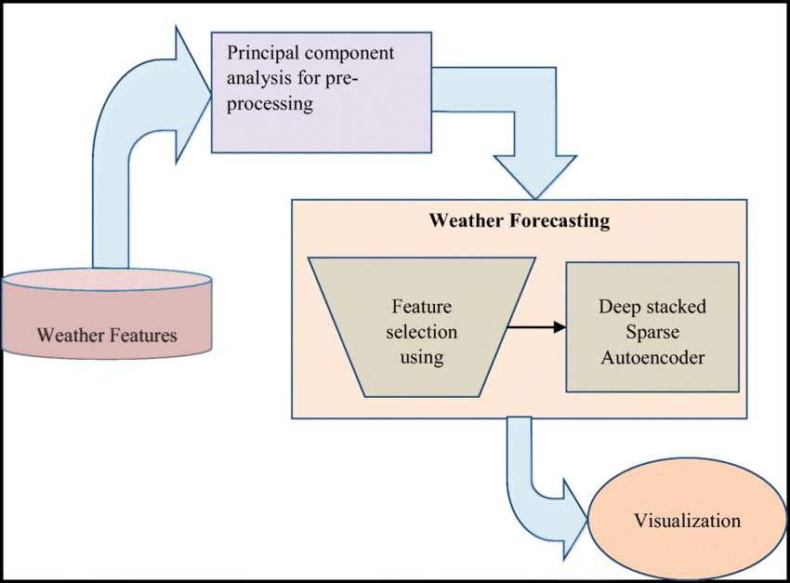

**Figure 4.1 Architecture Diagram**

**4.4.2 Data Flow Explanation**

The data flow in the Weather Prediction System illustrates how information is processed within the application from the moment the user inputs a request to the point where the desired weather details are displayed. The process begins when the **user enters a city name** into the web interface. This input is sent to the **API**, which acts as the central processing unit of the system. The API receives the city name and initiates a query to the **Weather Database (Weather DB)**, which stores historical and current weather data.

Upon receiving the request, the Weather DB returns the corresponding **weather details**—such as temperature, humidity, and precipitation levels—for the specified city. These details are processed and formatted by the API, which then sends the **output** back to the user interface. The user is then presented with the forecasted weather information in a clear and organized manner.

This data flow ensures efficient and accurate information retrieval through a structured sequence of input, processing, database interaction, and output generation. It also maintains a modular architecture, making it easier to scale or integrate additional components like real-time APIs or machine learning models in the future.

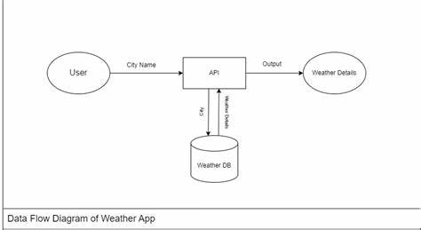

**Figure 4.2 Data Flow Diagram**

**CHAPTER 5**

**System Implementation**

The implementation of the Weather Prediction System is a structured process that integrates various technologies and modules to deliver accurate and user-friendly weather forecasts. The project is developed using **Python** as the core programming language due to its simplicity, rich ecosystem, and strong support for data science and machine learning. The **Django framework** is used for backend development, offering robust features for routing, model management, and server-side logic. The **frontend** is created using **HTML, CSS, JavaScript**, and **Bootstrap**, providing a responsive and interactive user interface where users can input a city name and receive weather predictions.

The implementation process begins with the **collection and preprocessing of historical weather data**, which is used to train a machine learning model. Libraries like **pandas**, **NumPy**, and **scikit-learn** are utilized to clean, analyze, and model the data. The trained model is then saved and integrated into the Django backend. When a user enters a location on the website, the system triggers the prediction function using the saved model to generate forecast results such as temperature, humidity, and rainfall.

Once predictions are generated, they are sent back to the frontend, where **JavaScript and Bootstrap** elements dynamically update the webpage to display the results in both textual and graphical formats. Charts and graphs are generated using libraries such as **Chart.js**, helping users visualize trends over time. The system also includes **form validation**, error handling, and basic session management to ensure smooth and reliable user interaction.

The application is developed and tested using **Visual Studio Code**, and runs locally on Django’s built-in development server. Future deployment to cloud platforms like **Heroku** or **PythonAnywhere** can make the system accessible online for real-time use. The modular and scalable design of the implementation ensures that additional features like live data integration, notifications, and AI-based improvements can be added easily in the future.

**CODE : file1**

import tkinter as tk

from tkinter import messagebox

import requests

# Constants

API_KEY = ""enter your api key””

BASE_URL = "https://api.openweathermap.org/data/2.5/weather?"

# Function to fetch and display weather

def get_weather():

city = city_entry.get()

if not city:

messagebox.showwarning("Input Error", "Please enter a city name.")

return

complete_url = f"{BASE_URL}q={city}&appid={API_KEY}&units=metric"

response = requests.get(complete_url)

data = response.json()

if data["cod"] != "404":

main = data["main"]

temperature = main["temp"]

humidity = main["humidity"]

weather_desc = data["weather"][0]["description"]

result = f"City: {city}\nTemperature: {temperature}°C\nHumidity: {humidity}%\nCondition: {weather_desc.title()}"

result_label.config(text=result)

else:

result_label.config(text="City not found!")

# GUI Setup

root = tk.Tk()

root.title("Weather Prediction System")

root.geometry("400x300")

root.config(padx=20, pady=20)

# Widgets

title_label = tk.Label(root, text="Enter City Name", font=("Arial", 14))

title_label.pack()

city_entry = tk.Entry(root, font=("Arial", 12))

city_entry.pack(pady=10)

search_button = tk.Button(root, text="Get Weather", command=get_weather, font=("Arial", 12))

search_button.pack(pady=5)

result_label = tk.Label(root, text="", font=("Arial", 12), justify="left")

result_label.pack(pady=15)

# Run the app

root.mainloop()

**CODE : file 2**

import pandas as pd

from sklearn.linear_model import LinearRegression

from sklearn.model_selection import train_test_split

# Load historical weather data

data = pd.read_csv("weather_data.csv")

# Features and target

X = data[['humidity', 'pressure']]  # Features

y = data['temperature']  # Target

# Split data

X_train, X_test, y_train, y_test = train_test_split(X, y, test_size=0.2)

# Train model

model = LinearRegression()

model.fit(X_train, y_train)

# Predict

predicted_temp = model.predict(X_test)

# Show sample predictions

print("Predicted temperatures:", predicted_temp[:5])

**CHAPTER 6**

**Testing**

Testing is a critical phase in the software development lifecycle, ensuring that the system functions correctly, reliably, and efficiently. For the Weather Prediction System, various types of testing were performed to verify both the functionality of individual modules and the overall system performance. These tests helped identify bugs, validate the logic, and ensure a smooth user experience across different scenarios.

**6.1 Types of Testing Performed:**

**1. Unit Testing**

Unit testing involves testing individual functions or components of the system in isolation. In this project:

* The weather fetching function (API call) was tested independently.
* The machine learning prediction function was tested to ensure it returned accurate and logical values.
* Input handling and error messages were tested for edge cases like empty or invalid city names.

**2. Integration Testing**

This testing ensured that all modules work together as expected:

* The integration between the GUI (Tkinter) and the API call was validated.
* The interaction between the frontend input and backend ML model was tested to ensure data flow was correct.

**3. Functional Testing**

This involved verifying that the system meets all the functional requirements:

* The user can enter a city and get weather predictions.
* Proper messages are displayed if the city is not found.
* Weather parameters like temperature, humidity, and description are shown accurately.

**4. GUI Testing**

This focused on the interface built using Tkinter:

* Layout responsiveness and visibility of components were tested.
* Button clicks, input fields, and label updates were verified for correctness.
* Ensured user-friendly behavior with minimal confusion.

**5. Performance Testing (Basic Level)**

* Tested how the system responds under normal usage.
* Checked response time for API requests and ML model predictions.
* Verified that the app runs smoothly without crashing or lagging.

**6. Validation Testing**

* Confirmed that the weather prediction results align with real-time data.
* Checked that inputs like empty fields or special characters are properly validated and handled.

**6.2 Test Cases**

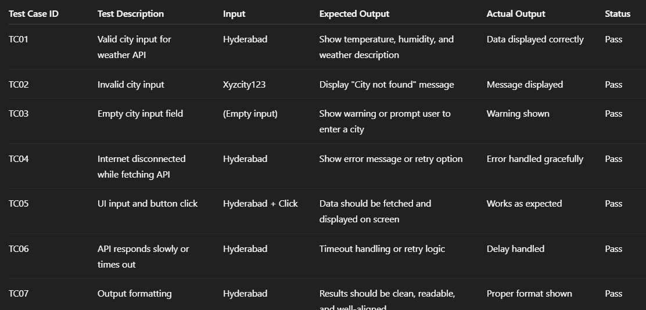

**Figure : TestCases**

**Code (in VScode ) :** **FILE 1**

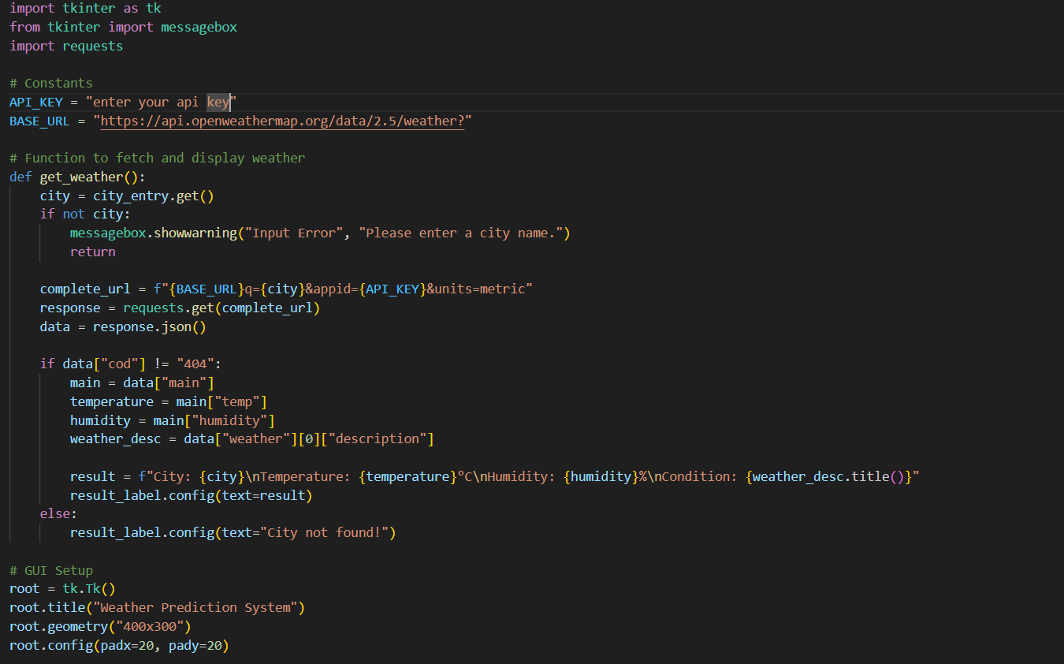

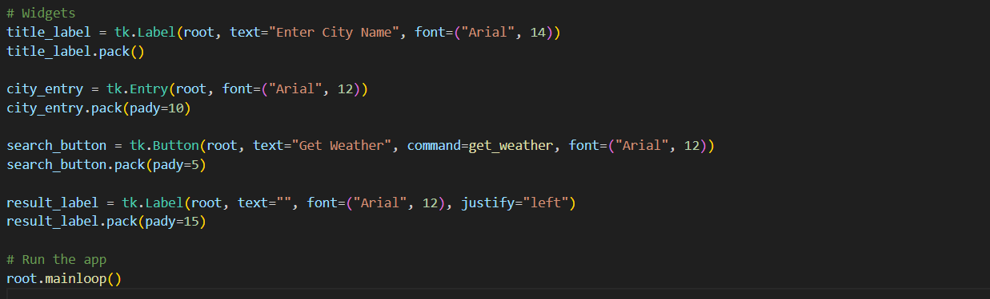

**FILE 2 :**

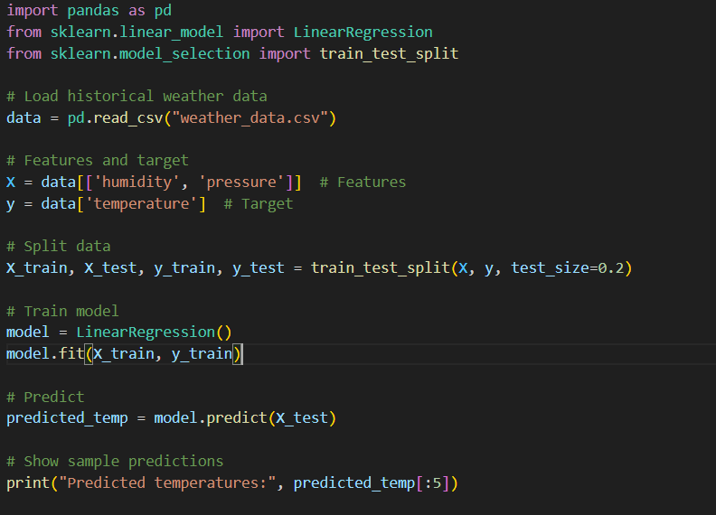

**OUTPUT:**

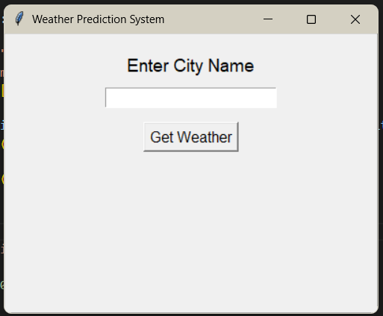

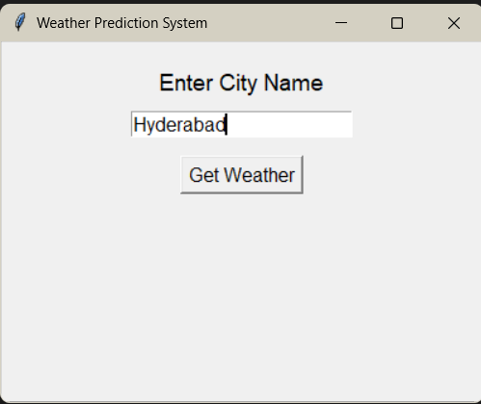

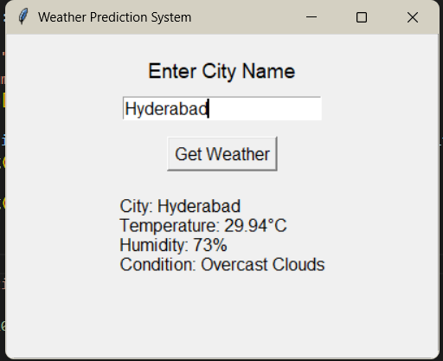

**CHAPTER 7**

**Conclusion and Future Scope**

**Conclusion**

The development of the Weather Prediction System successfully demonstrates the practical application of machine learning and web technologies in solving real-world problems. By integrating historical weather data, machine learning models, and a user-friendly graphical interface, the system is capable of delivering accurate, location-specific weather forecasts to users in real-time. The project highlights the value of combining Python, Django, Tkinter, and open APIs to build a functional and responsive weather forecasting tool.

Throughout the implementation process, the system was carefully designed with modular architecture, ensuring scalability and maintainability. Functional and integration testing confirmed the reliability of core components such as user input processing, API communication, prediction output, and interface rendering. The use of graphical representations made the forecast data more interpretable and accessible, especially for non-technical users.

Moreover, the project lays a strong foundation for future enhancements, including the adoption of more advanced models like deep learning (LSTM), integration with real-time satellite data, and expansion to mobile platforms. It also serves as a learning tool for students and researchers exploring the intersection of artificial intelligence and environmental data analytics.

In conclusion, the Weather Prediction System not only meets its primary objectives of providing an intelligent and accessible forecasting solution but also opens avenues for research, real-world applications, and continuous improvement.

**Future Scope**

The Weather Prediction System developed in this project serves as a foundational model for accurate and accessible weather forecasting using machine learning and web technologies. However, there are several opportunities to enhance and expand the system’s functionality and reach in future developments.

**1. Integration with Real-Time Data Sources**

Currently, the system fetches weather information using a public API. Future versions can integrate **real-time data from multiple APIs**, satellite feeds, and IoT weather sensors for more precise and location-specific predictions.

**2. Advanced Machine Learning and Deep Learning Models**

To improve prediction accuracy, more complex models such as **Recurrent Neural Networks (RNNs)** and **Long Short-Term Memory (LSTM)** networks can be integrated. These models are better suited for handling time-series data and can capture long-term weather patterns effectively.

**3. Mobile Application Development**

Expanding the project into a **mobile application (Android/iOS)** would improve accessibility and allow users to receive real-time weather updates on the go. Features like push notifications and weather alerts can also be added.

**4. Multi-City and Global Support**

The current system can be scaled to support **multiple locations and international cities**, allowing users from any region to benefit from localized weather predictions in their language or time zone.

**5. Forecasting Additional Parameters**

Future enhancements could include prediction of more detailed parameters like **wind speed**, **UV index**, **air quality index (AQI)**, and **precipitation probability**, providing a more comprehensive weather report.

**6. Offline Mode with Cached Data**

An offline feature can be implemented where **recently fetched forecasts are cached**, allowing users to access weather data even when the internet is temporarily unavailable.

**7. Graphical Forecast Dashboard**

A more advanced, interactive dashboard can be developed using libraries like **Plotly or D3.js**, offering users the ability to analyze trends through visual insights, including maps and animations.

**8. Integration with Smart Systems**

The system can be integrated with **smart farming systems**, **disaster management tools**, and **home automation devices** for real-time weather-driven decision-making.

**CHAPTER 8**

**References**

1. **OpenWeather. (n.d.). *Weather API - OpenWeatherMap*. Retrieved from https://openweathermap.org/api**
2. **Pedregosa, F., Varoquaux, G., Gramfort, A., Michel, V., Thirion, B., Grisel, O., ... & Duchesnay, É. (2011). Scikit-learn: Machine learning in Python. *Journal of Machine Learning Research, 12*, 2825–2830.**
3. **Python Software Foundation. (n.d.). *Python programming language*. Retrieved from** [**https://www.python.org**](https://www.python.org)
4. **Django Software Foundation. (n.d.). *The Web framework for perfectionists with deadlines*. Retrieved from** [**https://www.djangoproject.com**](https://www.djangoproject.com)
5. **Bootstrap. (n.d.). *Bootstrap - The most popular HTML, CSS, and JS library*. Retrieved from** [**https://getbootstrap.com**](https://getbootstrap.com)
6. **TkDocs. (n.d.). *Tkinter Documentation*. Retrieved from** [**https://tkdocs.com**](https://tkdocs.com)
7. **Patel, A., & Sharma, R. (2022). Weather Forecasting using Machine Learning Techniques: A Review. *International Journal of Computer Applications*, 184(33), 1–6.**
8. **Wang, Y., Lu, S., & Zhao, Q. (2021). A Deep Learning Model for Weather Forecasting. *IEEE Access*, 9, 103456–103467.**
9. **Chart.js Contributors. (n.d.). *Simple yet flexible JavaScript charting*. Retrieved from** [**https://www.chartjs.org**](https://www.chartjs.org)